**JULY & AUGUST**

* **School Supplies**
* **Pencils**
* **Pens**
* **Notebooks**

**MARCH& APRIL**

* **Socks**
* **Underwear**

**September& October**

* **Filler Items**
* **Small Toys**
* **Catch UP**
* **Stuffed Animals**

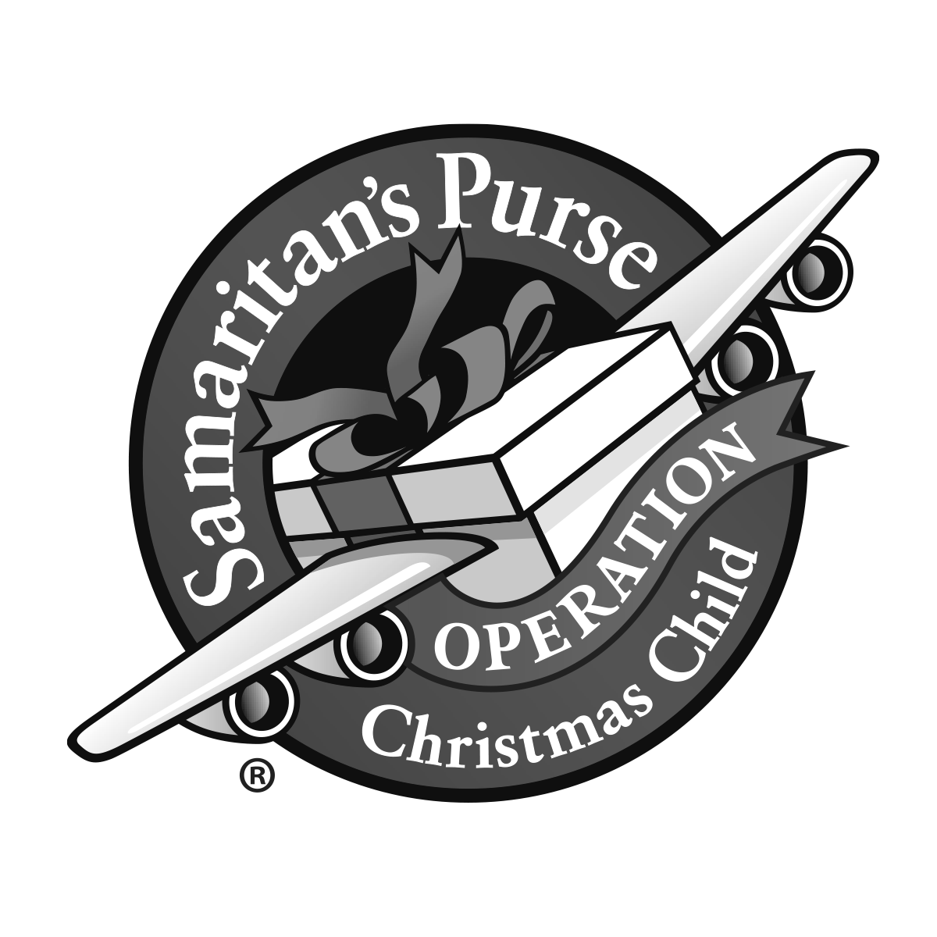

**Donations: Monetary donations can be made towards to purchase of bulk items. Many items are purchased in bulk to get the best possible price. Some items purchased in bulk include balls, crayons, coloring books, washcloths, hair accessories etc. Please prayerfully consider giving to shipping or shopping throughout the year. This year’s goal will be based off of items and donations given. I am calling it a God-sized goal. Please pray about how God wants you to be a part of this ministry and sharing the gospel through shoeboxes. He did things we couldn’t imagine during a pandemic year. We look forward to seeing him work through you in 2021!**

**MAY & JUNE**

* **DOLLS**
* **Stuffed Animals**
* **Flip Flops**

NCBC Operation Christmas Child 2021

Collection Calendar

